**University Database**:

A database management system (DBMS) is a collection of interconnected data and a set of applications for accessing that data. A database is a collection of data that contains information relevant to a company. A database management system's primary purpose is to provide an easy and efficient method for storing and retrieving database information. The schema defines a university database organized by courses, students, instructors, departments, and classrooms. Here's a summary of each table and how they are related:

# Classroom

* **Attributes**: building, room number, capacity
* **Purpose**: Stores information about university classrooms, including the building and room numbers, and the seating capacity of each room.

# Department

* **Attributes**: dept name, building, budget
* **Purpose**: Contains information about academic departments, including each department's name, the building where it is located, and its budget.

# Course

* **Attributes**: course id, title, dept name, credits
* **Purpose**: Represents courses offered by the university. Each course has a unique identifier, a title, the department it belongs to, and the number of credits it offers.

# Instructor

* **Attributes**: ID, name, dept name, salary
* **Purpose**: Holds information on instructors, including their unique ID, name, the department they belong to, and their salary.

# Section

* **Attributes**: course id, sec id, semester, year, building, room number, time slot id
* **Purpose**: Defines specific sections of courses being taught. Each section has a unique combination of course ID and section ID for a particular semester and year, along with the classroom and time slot where the section is held.

# Teaches

* **Attributes**: ID, course id, sec id, semester, year
* **Purpose**: Represents the relationship between instructors and the sections they teach. It links an instructor to a course section offered in a particular semester and year.

# Student

* **Attributes**: ID, name, dept name, tot cred
* **Purpose**: Stores student information, including a unique student ID, name, the department they are enrolled in, and their total completed credits.

# Takes

* **Attributes**: ID, course id, sec id, semester, year, grade
* **Purpose**: Captures information about the courses students are enrolled in, including the grade they received. Each record links a student to a specific course section in a given semester and year.

# Advisor

* **Attributes**: student_ID, i_ID
* **Purpose**: Represents the advising relationship between students and instructors. Each record links a student to an instructor who serves as their advisor.

# Time Slot

* **Attributes**: time slot id, day, start time, end time
* **Purpose**: Defines the schedule for class times, with each time slot having a unique ID, day of the week, and start and end times.

# Prereq

* **Attributes**: course id, prereq id
* **Purpose**: Specifies prerequisite relationships between courses, with each record indicating that one course is a prerequisite for another.

**Relationships and Dependencies:**

* **Department** is associated with **Classroom**, **Course**, **Instructor**, and **Student** tables through dept name.
* **Instructor** and **Student** are linked through the **Advisor** table.
* **Course** has a prerequisite relationship with itself via the **Prereq** table.
* **Instructor** is associated with **Section** through the **Teaches** table, indicating which courses they teach.
* **Student** is associated with **Section** via the **Takes** table, indicating courses they enroll in.
* **Time Slot** is linked to **Section** to define the schedule for each course section.

**University database Schema**:

*classroom(building, room number, capacity)**department(dept name, building, budget) course(course id, title, dept name, credits) instructor(ID, name, dept name, salary) section(course id, sec id, semester, year, building, room number, time slot id) teaches(ID, course id, sec id, semester, year) student(ID, name, dept name, tot cred) takes(ID, course id, sec id, semester, year, grade) advisor(s_ID, i_ID) time slot(time slot id, day, start time, end time) prereq(course id, prereq id)*

**University database Schema diagram:**

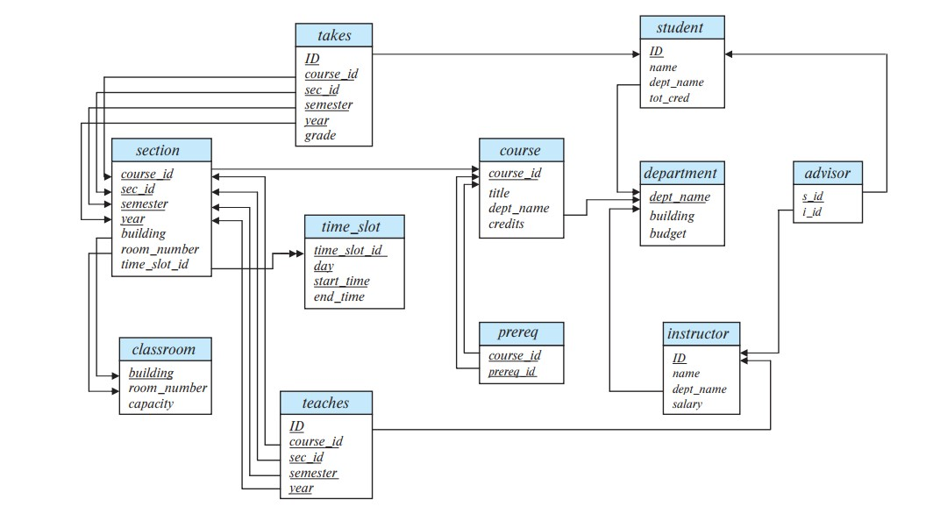

**University database E-R diagram:**

